**Design And Analysis of Algorithm**

**Project Report**

|  |  |
| --- | --- |
| **How it will work(Important!):** | This project works on server either the **Xammp server** or **live server (on vscode)** can be used |

**Group Members:**

* Syed Usman Ahsan ( 18k-0139 )
* Muhammad Talha ( 18k-0224)

**Section: 5-C**

**Abstract:**

We did implementation of some famous dynamic problem algorithms in our web application using javascript and ajax where user can choose any any algorithm and can obtain results provided by inputs.

**Introduction:**

The Dynamic Programming is one of the different algorithm paradigm. In this approach, the problems can be divided into some sub-problems and it stores the output of some previous subproblems to use them in future. It helps to reduce the computational time for the task.

The following chart shows the complexities of these dynamic algorithm:

|  |  |
| --- | --- |
| **Dynamic Algorithms** | **Time Complexities** |
| Longest Common Subsequence | O(n*m) n and m are stings length |
| Shortest Common Supersequence | O(n*m) n and m are stings length |
| Levenshtein Distance(edit-distance) | O(n1*n2) |
| Longest Increasing Subsequence | O(n^2) |
| Matrix Chain Multiplication | O(n^3) |
| 0/1 Knapsack | O(nW) where n is the number of items and W is the capacity |
| Partition Problem | O(sum * n) |
| Rod Cutting Problem | O(n^2) |
| Coin Change Problem | O(mn) |
| Word Break Problem | O O(n * s) where s is the length of the largest string in the dictionary and n is the length of the given string. |

**Proposed system:**

* User is presented with main page to select any algorithm.

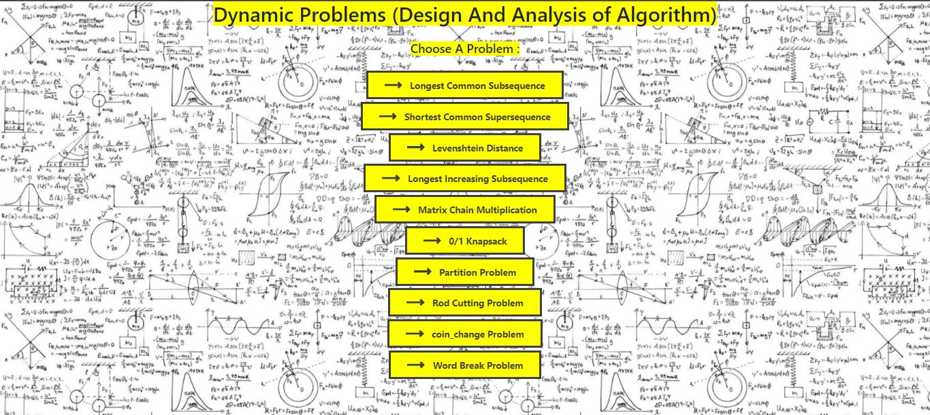

* Now the user can select any of the provided Algotrithms.to run and check the the answers on any of the 10 input.

**Diagram of the Project Setup(Deploment Diagram):**

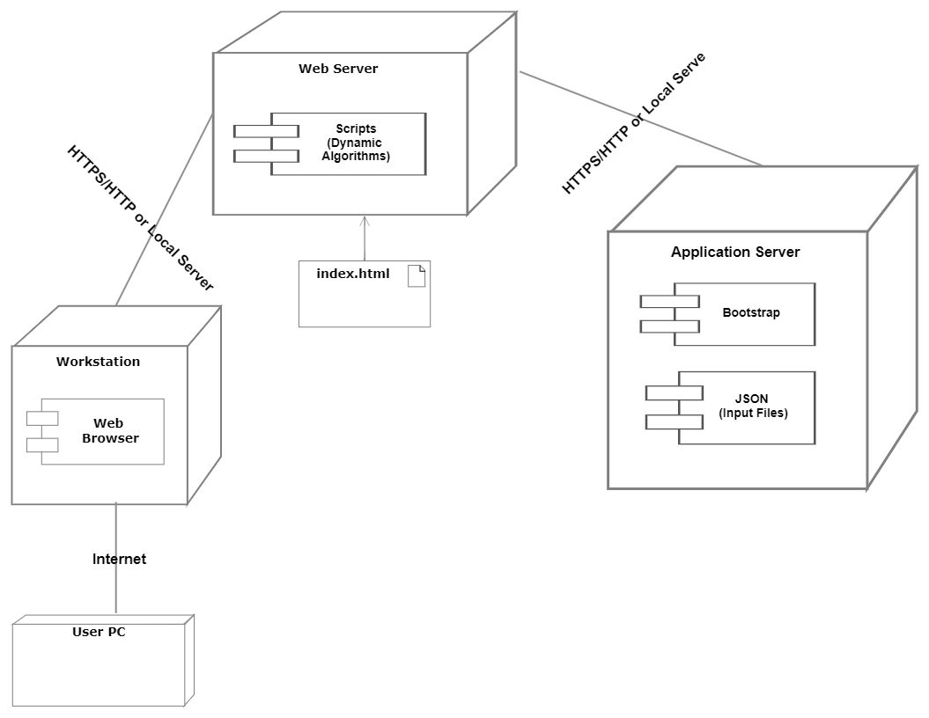

**Experimental Setup:**

We have designed different inputs for different algorithms.Each algorithm has random 10 datasets of values according to the algorithms which are stored in input files in **JSON** format.When an algorithm is selected by the user the 10 inputs are retrieved from the input files using **AJAX** .

Then the respective algorithm is applied to that particular input.

The inputs are in accordance with the guidelines provided in the project description.

We have also attached the input files with this project for better understanding of inputs along with the demo video.

**Results and Discussion:**

After user select any input,Following is the results:

This is the example of Shortest Common Supersequence :

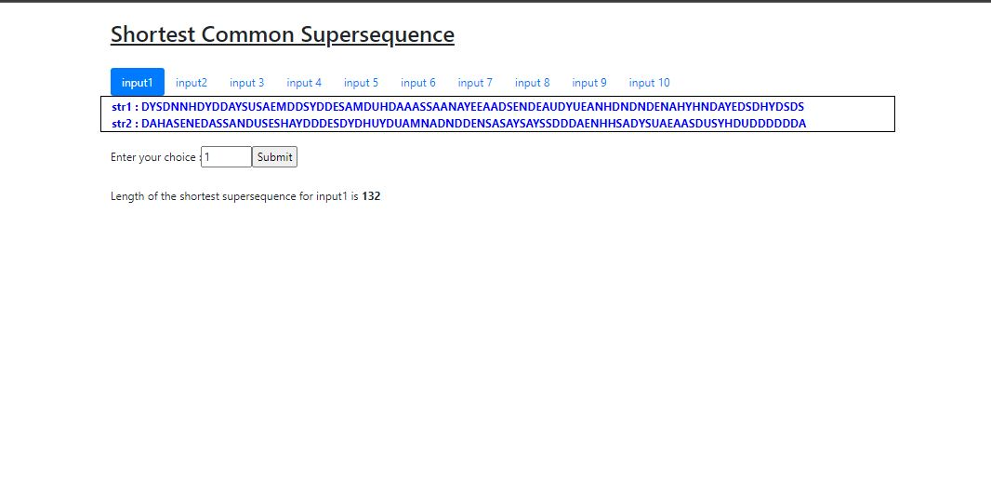

**Conclusion:**

By implementing these algorithms, we were able to learn to implement algorithms and got to know time complexities for algorithms on our provided inputs.We were able to know that it is mainly an optimization​ over plain recursion. In addition to it the dynamic approach very much faster as compared to recursive approach it solves exponential time problem in polynomial time.

**References:**

* <https://www.geeksforgeeks.org/longest-common-subsequence-dp-4/>
* [Top 10 Dynamic programming problems for interviews | by Coding Freak | Techie Delight | Medium](https://medium.com/techie-delight/top-10-dynamic-programming-problems-5da486eeb360)

**DEMO Video link:**

Press ctrl+click to open link.

[Dynamic Programming - Personal - Microsoft​ Edge 2021-01-19 22-29-21.mp4 - Google Drive](https://drive.google.com/file/d/1Vx2WNdkuQIsrISv466jhw7haVpQYdpeC/view)